
MINI PROJECT Ã¢â‚¬â€œ BCA20090
SY BCA 2025-26
SYNOPSIS REPORT
TITLE:
CuraVision AI Ã¢â‚¬â€œ AI Powered Medical Image Classification System

Submitted by:
- Vedant Khedkar - 1272240644
- Sakshi Pandey - 1272240631

Guided By:
Dr. Pradeep Kumar Tiwari
Mrs. Aparna Kulkarni

Dr. Vishwanath Karad MIT World Peace University
Department of Computer Science and Applications
Academic Year: 2025-26
Date: 1st February 2026

Index
Sr. No. | Contents
1 | Nomenclature/Notations
2 | Abstract
3 | Motivation
4 | Literature review
5 | Problem Formulation and Objectives
 | 5.1 Problem Statement
 | 5.2 Main Objective
 | 5.3 Specific Objective
6 | Methodology/Planning of Work
 | 6.1 Requirement Analysis
 | 6.2 System Architecture
 | 6.3 Development Phases
7 | System Structure / Architecture
 | 7.1 Dataset and Meta Data
 | 7.2 Dataset Integrity & Validation
8 | Development Phases and Testing
9 | Facilities Required for Proposed Work
 | 9.1 Hardware Requirements
 | 9.2 Software Requirements
10 | Bibliography/ References

Nomenclature/Notations
The following abbreviations and technical terms are used throughout this synopsis to describe the architecture and functionality of the CuraVision - AI system:
Here is the refined list with unnecessary spaces removed and key terms formatted for better readability:
- Artificial Intelligence (AI): A branch of computer science focused on building systems capable of performing tasks that normally require human intelligence, such as learning, reasoning, and decision-making.
- Convolutional Neural Network (CNN): A specialized deep learning architecture designed to process and analyze visual data by learning hierarchical spatial features.
- Chest X-ray (CXR): A radiographic imaging technique used to diagnose lung diseases, including Pneumonia.
- Out-of-Distribution (OOD): Input data that does not belong to the training dataset, often causing unreliable predictions.
- Transfer Learning: A machine learning technique where knowledge gained from one task is applied to a related task.
- MobileNetV2: A lightweight CNN architecture optimized for performance and computational efficiency.
- Flask: A Python micro-framework used for developing backend web applications.
- TensorFlow / Keras: Deep learning libraries used to design, train, and deploy neural networks.
- Confidence Score: A probability value representing prediction certainty.

Abstract
CuraVision AI is an educational AI-powered clinical decision support system that assists healthcare professionals in preliminary pneumonia triage using Chest X-ray (CXR) images. The updated system now combines model inference, doctor authentication, case management, and AI-generated support text in one integrated workflow.
The proposed system uses a two-stage AI pipeline with clinical workflow integration:
- Stage 1: Chest X-ray Suitability Validation - A CLIP-based detector checks whether the uploaded image is a valid chest X-ray before diagnosis, reducing Out-of-Distribution (OOD) errors.
- Stage 2: Pneumonia Classification - Valid chest X-rays are classified as NORMAL or PNEUMONIA by a TensorFlow/Keras transfer-learning model (MobileNetV2-based).
The models are integrated into a Flask web application with doctor login, OTP verification, case history, confidence reporting, and an AI Helper page for symptom-based recommendations.

Motivation
Motivation for CuraVision AI
The motivation for developing CuraVision AI arises from the growing demand for efficient and reliable diagnostic tools in healthcare. Pneumonia continues to be a leading cause of respiratory illness globally, requiring rapid and accurate diagnosis.
Manual interpretation of Chest X-ray images is time-consuming and dependent on expert radiologists. In rural and under-resourced medical facilities, access to such expertise is limited, leading to delayed diagnoses and increased risk to patients.
CuraVision AI aims to bridge this gap through the following objectives:
- Reducing Diagnostic Delays: Providing automated preliminary analysis of X-ray images to speed up the clinical workflow.
- Improving Reliability: Addressing the lack of robustness in traditional AI models by introducing a dedicated image validation mechanism.
- Educational Foundation: Serving as a platform for understanding deep learning, medical imaging, and ethical AI deployment.

Literature Review

To understand the necessity of CuraVision AI, it is essential to analyze the existing methods of medical image analysis and their respective limitations. The following table provides a comparison between traditional methods and the proposed digital solution.

Existing Method | Pros | Cons
Manual/Physical Diagnosis | Relies on direct human expertise and clinical intuition. | Time-consuming; highly dependent on expert availability; prone to fatigue.
Traditional Image Processing | Enhances visual features like edges and contrast for better viewing. | Limited accuracy; cannot automate complex pattern recognition.
Traditional Machine Learning | Uses established classifiers like SVM and Random Forest. | Requires handcrafted features and extensive domain expertise; lacks scalability.
Standard Deep Learning | Achieves state-of-the-art performance through transfer learning. | Often ignores the Out-of-Distribution (OOD) problem, leading to unreliable predictions.
CuraVision AI (Proposed) | Two-stage CNN pipeline; validation-first approach; OOD mitigation. | Requires significant initial computational resources for model training.

Problem Formulation & Objectives
Problem Statement and Objectives
The development of CuraVision AI is guided by a clear focus on improving the reliability of automated medical diagnostics. Below are the core challenges and the structured goals defined for this project.
Problem Statement
Existing AI-based medical image classification systems generate predictions for any input image without validating its medical relevance. This leads to incorrect diagnoses and reduces trust in AI-assisted healthcare systems.

Main Objective
To design and develop a reliable AI-powered system capable of detecting Pneumonia from Chest X-ray images with high accuracy and confidence.

Specific Objectives
- Implement a two-stage CNN pipeline: Develop a structured flow that first validates the image type before performing medical classification.
- Detect and reject Out-of-Distribution (OOD) images: Ensure the system identifies and filters out non-medical or unrelated images to maintain diagnostic integrity.
- Classify Chest X-ray images: Use deep learning to accurately categorize validated scans into NORMAL or PNEUMONIA.
- Display prediction confidence scores: Provide transparency by showing a probability value representing the certainty of each prediction.
- Deploy a scalable web-based application: Integrate the models into a Flask framework to allow for real-time image uploads and results.

Methodology/ Planning of Work

6.1 Requirement Analysis
The requirement analysis phase for CuraVision AI defines the necessary technical environment and functional needs to ensure the system operates reliably within a medical diagnostic setting.
Functional Requirements
- Image Validation: The system must identify whether an uploaded image is a chest X-ray using a dedicated suitability stage before classification.
- High-Recall Classification: The core classifier must categorize validated scans into NORMAL or PNEUMONIA with medically useful recall for pneumonia cases.
- Real-time Clinical Feedback: The web interface must provide prediction, confidence score, and contextual AI insights immediately after upload.
- Case and Audit Management: The backend must store patient cases, prediction outputs, and timestamps for later review by doctors.

Software Requirements
To develop and deploy the current pipeline, the following software stack is used:
- Programming Language: Python 3.11.x (core backend and AI integration).
- Machine Learning Frameworks: TensorFlow/Keras, scikit-learn, and Transformers (CLIP support).
- Web Framework: Flask with Flask-SQLAlchemy and Flask-Bcrypt.
- Image Processing: OpenCV and Pillow (preprocessing and upload validation support).
- Environment Management: Python virtual environment (.venv) with pip-based dependency management.
- Version Control: Git and GitHub (collaborative development and release tracking).

Hardware Requirements
While the system is designed to be lightweight using MobileNetV2, the following hardware specifications are recommended for optimal training and inference:
- Processor: Multicore CPU (Intel i5/i7 or equivalent) for handling concurrent web requests and local preprocessing.
- Memory (RAM): Minimum 8GB (16GB recommended) to support model loading and image batch processing.
- Storage: Approximately 2GB of free space for the Kaggle Chest X-ray Dataset and model artifacts.
- GPU (Optional): An NVIDIA GPU with CUDA support is recommended to reduce the model training time significantly.
In this initial phase, the primary focus is understanding the needs of healthcare professionals and medical facilities. This involves identifying critical factors in Pneumonia detectionÃ¢â‚¬â€such as the necessity for high recall (96.67%)Ã¢â‚¬â€and determining the most effective data pipeline for high-accuracy reporting. Planning also includes establishing a validation mechanism to address the Out-of-Distribution (OOD) problem, ensuring the system only processes relevant Chest X-ray data.

6.2 Implementation Phases
- System Design: A modular architecture was designed with authentication, upload/inference flow, AI helper logic, and persistent case records.
- Frontend Development: A responsive Jinja2 + Tailwind interface was built for dashboard, upload, case details, and AI helper workflows.
- Backend Development: Flask routes implement authentication, OTP verification, prediction APIs, and case retrieval endpoints.
- Database Integration: SQLite via SQLAlchemy stores doctor profiles, patient cases, predictions, confidence values, and metadata.

6.3 System Architecture
The updated CuraVision AI architecture follows a secure client-server model connecting doctor workflows with an AI inference pipeline and persistent storage.
Workflow Components
- Access Layer: Doctors authenticate through registration/login and OTP verification before accessing clinical features.
- Validation Layer (OOD Control): Uploaded images are screened for chest X-ray suitability using CLIP-based validation to reduce invalid inference.
- Inference Layer: Valid images are processed by the MobileNetV2-based classifier to produce NORMAL or PNEUMONIA predictions with confidence.
- Data Layer: SQLite stores uploaded case records, symptoms, AI insights, predictions, confidence, and timestamps for follow-up.
- Clinical Dashboard Layer: Doctors review recent/high-risk cases, inspect case details, and use AI Helper recommendations to support decisions.

6.4 Database Design

Figure 6.4: Database Design Diagram
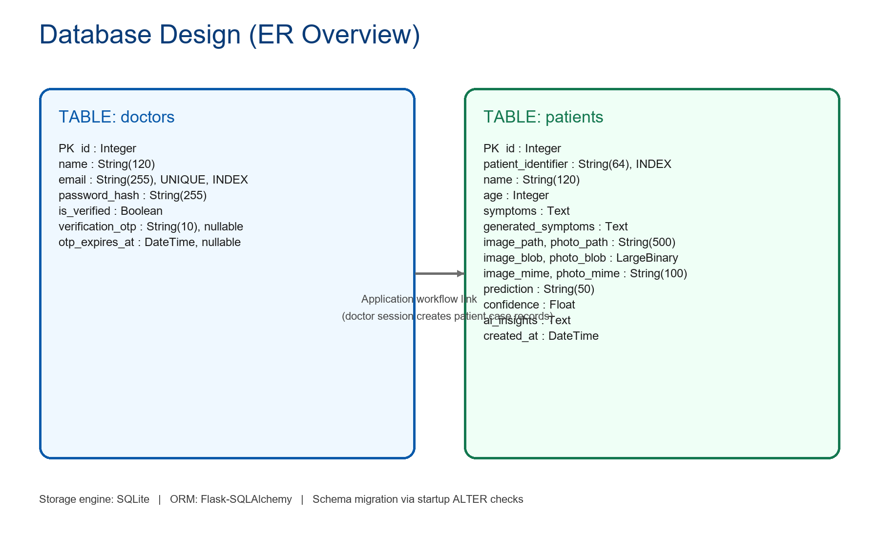
The ER-style diagram above shows key entities, important attributes, and the workflow relationship used by the current application design.

Database Overview
The project uses SQLite as the primary relational database for local deployment and Flask-SQLAlchemy as the ORM layer. The database stores doctor authentication details, OTP verification state, and complete patient case records (including prediction outputs and metadata).
At application startup, schema compatibility checks are run so older database files can be upgraded by adding missing columns without deleting existing data.
Database Technology
- Database engine: SQLite
- ORM: Flask-SQLAlchemy
- Password security: Flask-Bcrypt (hashed passwords, not plain text)
- Schema handling: Automatic table creation plus startup column-upgrade checks
Database Design
The current schema has two core tables:
- doctors: manages account, login verification, OTP lifecycle
- patients: stores each uploaded case and AI output for dashboard/history/report workflows
There is no explicit foreign key between doctors and patients in the current version. Case creation is controlled through authenticated sessions at the application layer.
Table 1: doctors
- id: Integer, Primary Key
- name: String(120), Not Null
- email: String(255), Not Null, Unique, Indexed
- password_hash: String(255), Not Null
- is_verified: Boolean, Not Null, Default False
- verification_otp: String(10), Nullable
- otp_expires_at: DateTime, Nullable
Table 2: patients
- id: Integer, Primary Key
- patient_identifier: String(64), Nullable, Indexed
- name: String(120), Not Null
- age: Integer, Not Null
- symptoms: Text, Not Null
- generated_symptoms: Text, Not Null, Default empty string
- image_path: String(500), Not Null
- photo_path: String(500), Nullable
- image_blob: LargeBinary, Nullable
- image_mime: String(100), Nullable
- photo_blob: LargeBinary, Nullable
- photo_mime: String(100), Nullable
- prediction: String(50), Not Null
- confidence: Float, Not Null
- ai_insights: Text, Not Null, Default empty string
- created_at: DateTime, Not Null, Default UTC timestamp
How Database Is Used in Workflow
- Create: New patient case row is inserted after successful image validation and prediction.
- Read: Dashboard, case history, case details, and patient report pages read stored rows.
- Update: OTP fields and verification status are updated during doctor onboarding/verification.
- Delete: Case delete removes both database record and related uploaded files.
Data Integrity and Validation
- Unique email constraint prevents duplicate doctor accounts.
- Patient identifier format is validated before use.
- OTP has expiry logic to prevent stale verification attempts.
- Uploaded file metadata is stored (MIME + path/blob) for reliable report rendering.

6.5 Database Tables
Doctors Table (doctors): Stores doctor profile, hashed password, verification OTP, and verification state for secure login and onboarding workflow.
Patients Table (patients): Stores patient identifier, demographics, symptoms, uploaded image paths/blob data, prediction result, confidence score, AI insights, and timestamp for each case report.

6.6 Project Flow Diagram
Figure 6.6: End-to-End Project Flow
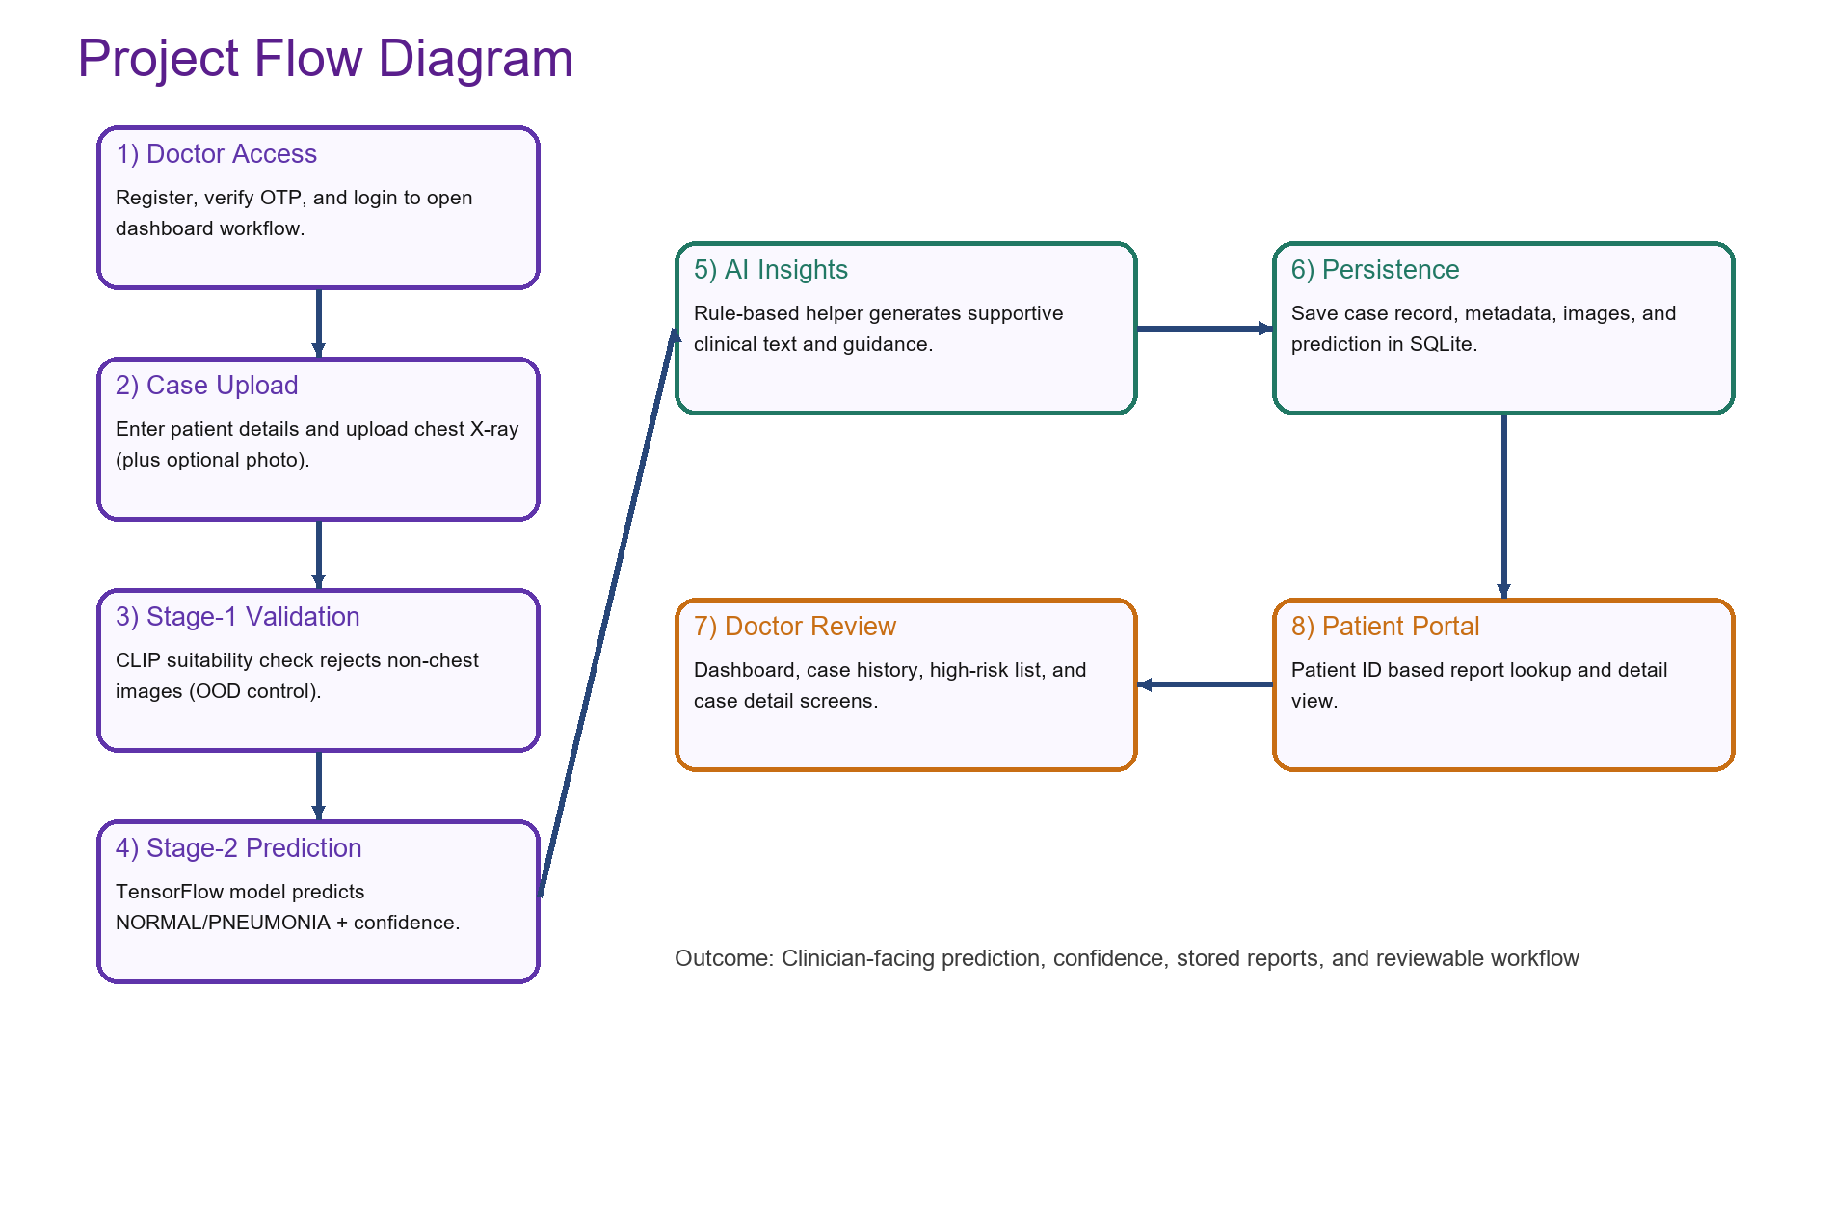
The flow diagram illustrates doctor onboarding, image validation, prediction, insight generation, storage, and report access steps.
6.7 Testing and Deployment
Development Phases and Testing
The implementation of CuraVision AI follows a structured lifecycle, moving from technical setup to real-world deployment and rigorous evaluation.
Development Phases
The development process is divided into key stages to ensure the system is both robust and scalable:
- Environment Setup: Configure Python environment and install TensorFlow, Flask, SQLAlchemy, Transformers, and related dependencies.
- Dataset Preparation: Organize chest X-ray datasets for training/validation/testing and maintain detector data for suitability checks.
- Preprocessing: Apply resizing, normalization, and augmentation pipelines to improve robustness and generalization.
- Model Training: Train/evaluate MobileNetV2-based pneumonia classifier and maintain chest X-ray suitability detector artifacts.
- Backend API Development: Build Flask endpoints for upload, prediction, case management, and helper recommendations.
Dataset Specifications
7. Dataset Specifications
CuraVision AI uses both structured application data and image datasets: SQLite stores operational records, while Kaggle chest X-ray directories provide training/validation/test image data.
Dataset Directory Structure
The following table defines the organization of the Kaggle files used to train, validate, and test the model.
Directory / Folder | Sub-Category | Data Type | Description
train/ | NORMAL / PNEUMONIA | .jpeg / .png | 5,216 images used for model weight adjustment and feature extraction.
test/ | NORMAL / PNEUMONIA | .jpeg / .png | 624 images used for final performance evaluation and accuracy metrics.
val/ | NORMAL / PNEUMONIA | .jpeg / .png | Images used for real-time validation during training to monitor for overfitting.

7.1. Data Attributes & Metadata
In addition to dataset-level image attributes, the deployed app maintains SQL-backed case metadata for each uploaded scan and prediction event.
- Image_ID / Case_ID: Unique identifiers for uploaded scans and patient cases used in application tracking.
- Label / Prediction: Ground-truth labels in training data and model outputs (NORMAL or PNEUMONIA) in deployment.
- Dimensions: Input images are standardized to model-compatible resolution (e.g., 224x224 for MobileNetV2 pipeline).
- Color Handling: Chest X-rays are preprocessed to match model input format while preserving diagnostic structures.
- Class Distribution: Training data remains imbalanced; evaluation emphasizes clinically meaningful recall and precision trade-offs.

7.2. Dataset Integrity & Validation
To maintain reliability in both training and deployment, CuraVision AI enforces the following validation constraints:
- Suitability Check: The Stage 1 validator filters non-chest images before medical classification is executed.
- Normalization: Pixel values are scaled consistently so model inference remains stable across uploads.
- Data Integrity: Input sanitation, file-type checks, and controlled preprocessing reduce corrupted or invalid samples.

Testing and Evaluation
8. Testing and Evaluations
To ensure the updated CuraVision AI system provides reliable support, the following testing protocols are used:
- Functional Testing: Verify registration/login, OTP flow, upload, prediction rendering, case views, and AI helper interactions.
- Validation Testing: Confirm Stage 1 suitability screening correctly identifies chest X-ray vs non-chest inputs.
- Model Evaluation: Assess classifier quality using precision, recall, F1-score, confusion matrix, and confidence behavior.
- Usability Testing: Validate that doctors can interpret outputs, confidence, and recommendations quickly from the dashboard UI.

INPUT : -

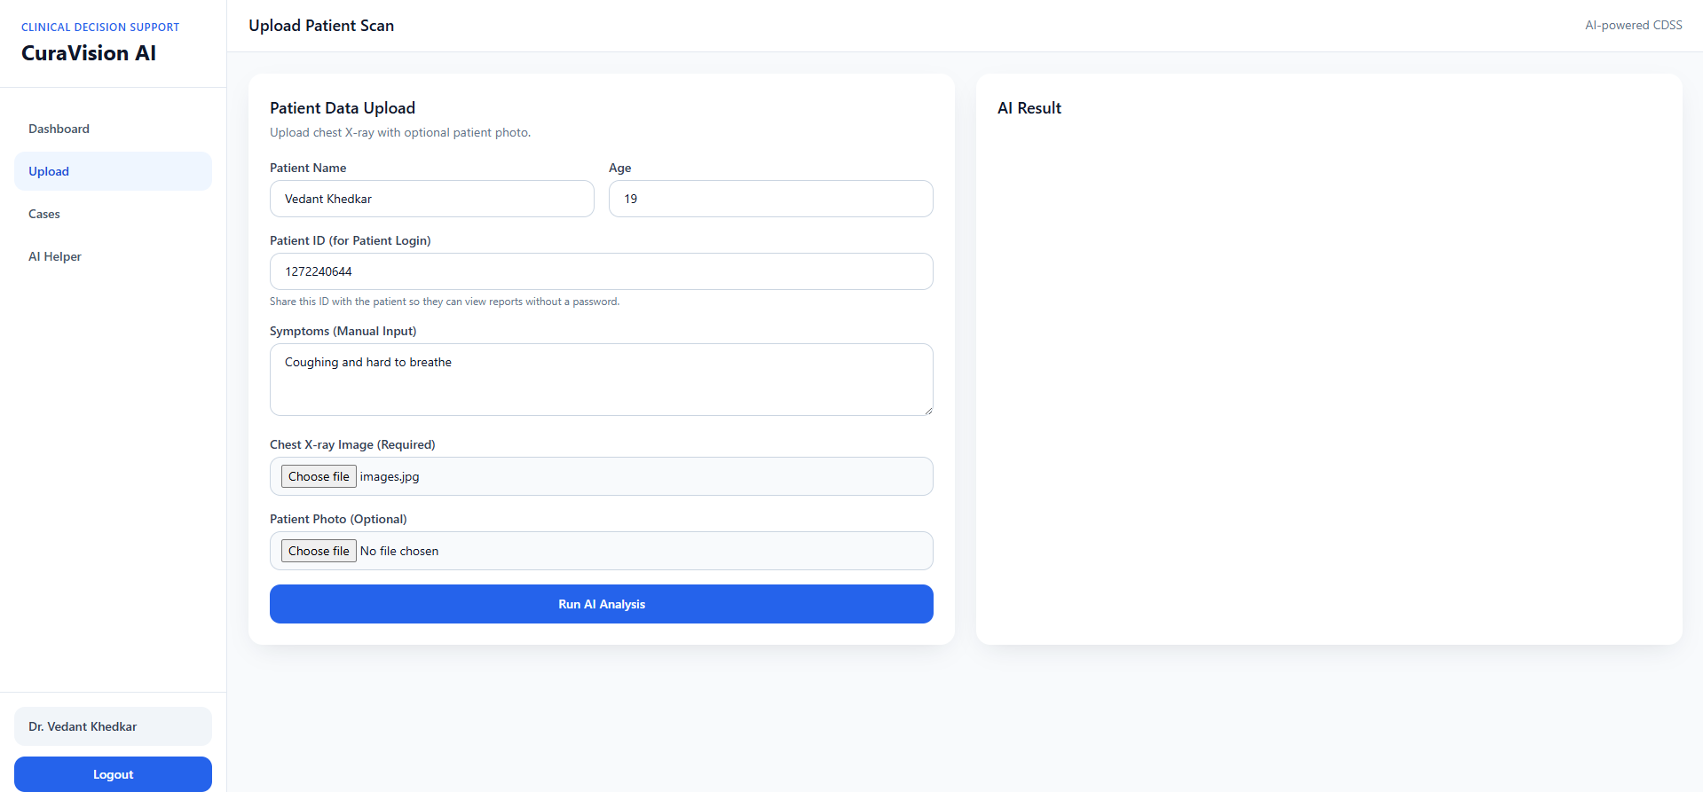

Output : -

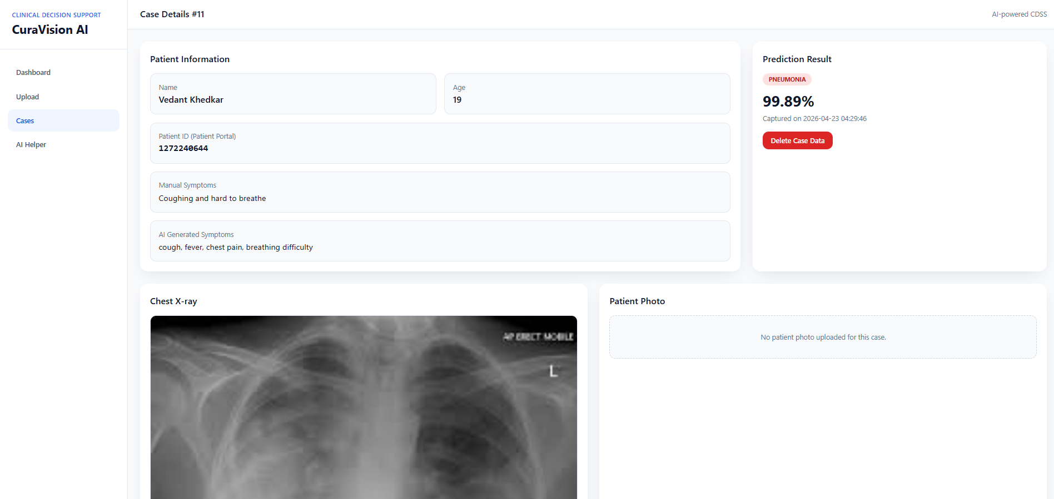

Patient Point of view for the case

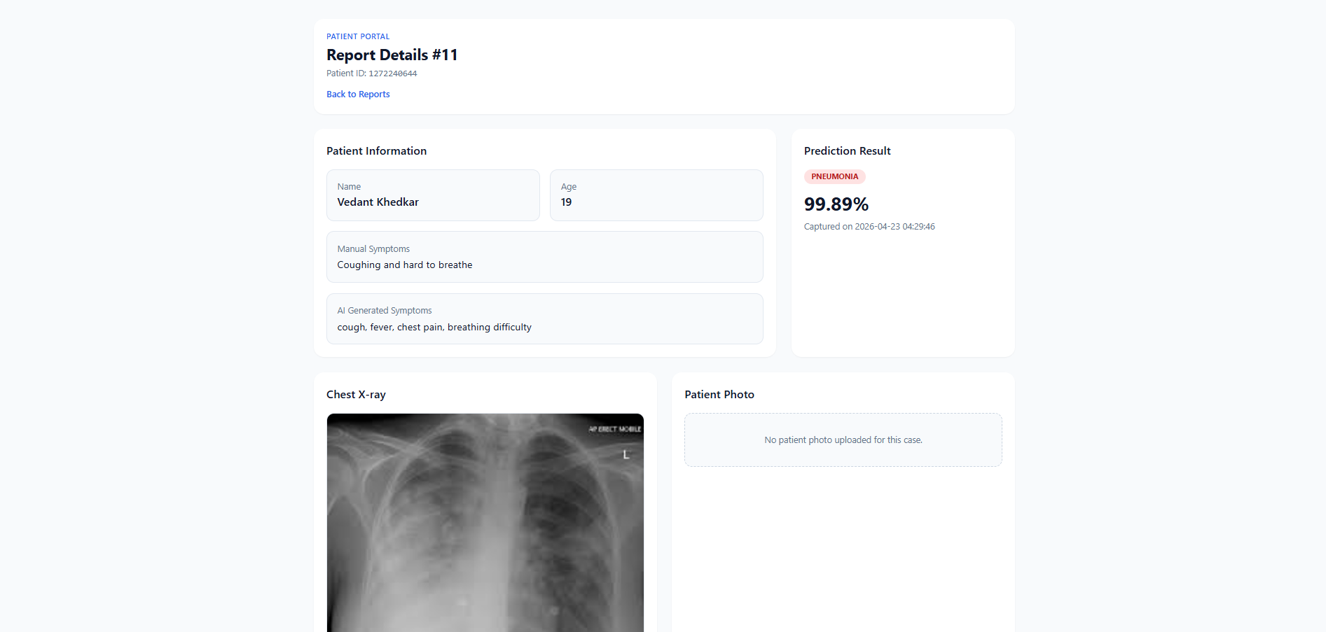

Facilities Required for Proposed Work
The following hardware and software facilities are required for the successful development and deployment of CuraVision AI:
- 9.1 Hardware Requirements:
  - Development Machine: Minimum 8 GB RAM (16 GB recommended) with a modern multi-core processor for model loading and local Flask execution.
  - Optional GPU Machine: NVIDIA CUDA-capable GPU is recommended for faster model training and experimentation.
  - Storage and Network: Sufficient storage for datasets/models and stable internet for dependency installation and repository sync.
- 9.2 Software Requirements:
  - Operating System: Windows, macOS, or Linux.
  - IDE: Visual Studio Code (recommended) or any Python-compatible IDE.
  - Version Control: Git and GitHub for source control and collaboration.
  - Frontend: Jinja2 templates with HTML, Tailwind utility classes, and JavaScript.
  - Backend: Python + Flask ecosystem (Flask-SQLAlchemy, Flask-Bcrypt, routing modules).
  - Database: SQLite (current implementation via SQLAlchemy ORM).

Bibliography/References
10. References
The following resources provided the foundational data, technical frameworks, and architectural principles required to develop CuraVision AI.
1. Kaggle Chest X-ray Dataset
The Kaggle Chest X-ray Dataset is a publicly available and widely referenced dataset used for academic research and educational projects in the field of medical image analysis. The dataset contains a large collection of labeled Chest X-ray images classified into categories such as NORMAL and PNEUMONIA. It is commonly used for training, testing, and validating deep learning models due to its standardized structure and reliable annotations. This dataset enables the exploration of Convolutional Neural Networks and transfer learning techniques while addressing real-world challenges in medical diagnosis.
2. TensorFlow & Keras Documentation
The official TensorFlow and Keras documentation provides comprehensive guidance on the design, training, optimization, and deployment of deep learning models. These resources cover essential concepts such as neural network architectures, loss functions, optimization algorithms, and model evaluation techniques. In the CuraVision AI project, these frameworks were used to implement CNN models, apply transfer learning, and manage the end-to-end training pipeline.
3. MobileNetV2 Research Paper
The MobileNetV2 research paper presents a lightweight and efficient Convolutional Neural Network architecture designed for high performance with reduced computational cost. The architecture introduces inverted residual blocks and linear bottlenecks, enabling faster inference while maintaining high accuracy. In this project, MobileNetV2 was utilized as a pre-trained backbone model through transfer learning, allowing for effective feature extraction and improved classification performance.
4. Flask Documentation
The Flask documentation provides detailed information on building web-based applications and APIs using the Flask micro-framework. Known for its simplicity and ease of integration with machine learning models, Flask was used in the CuraVision AI system to develop the backend server responsible for handling image uploads, processing model inference requests, and returning prediction results to the user interface.

